Common Versioning Strategies - Content Negotiation / Media Type Versioning

🌐 What is Content Negotiation / Media Type Versioning
# Source: AI Source: Provided by: [Data Path: Persons Table -> ID Column: 1, Name_En Column: Motasem Essam] -> From: [ChatGPT] on [1/19/2026]
Media Type Versioning (also called Content Negotiation Versioning) specifies the API version in the Accept or Content-Type header using a custom media type.
👉 Instead of changing the URL, the client tells the server:
“I want this version of the resource format.”

🔑 Key Points
# Source: AI Source: Provided by: [Data Path: Persons Table -> ID Column: 1, Name_En Column: Motasem Essam] -> From: [ChatGPT] on [1/19/2026]
- Version is included in the media type
  - Usually inside the Accept header
- Keeps URLs clean
  - Same endpoint for all versions
- Uses content negotiation
  - Server chooses response format based on header
- More RESTful approach
  - Focuses on representation, not endpoint

🧱 Example

Version 1
# Source: AI Source: Provided by: [Data Path: Persons Table -> ID Column: 1, Name_En Column: Motasem Essam] -> From: [ChatGPT] on [1/19/2026]
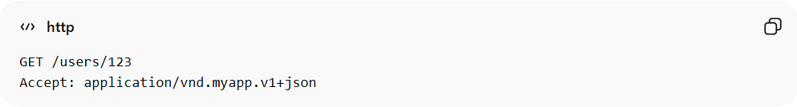
GET /users/123
Accept: application/vnd.myapp.v1+json
Response:
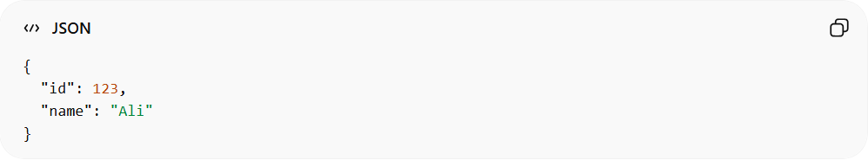
{
"id": 123,
"name": "Ali"
}

Version 2 (added email field)
# Source: AI Source: Provided by: [Data Path: Persons Table -> ID Column: 1, Name_En Column: Motasem Essam] -> From: [ChatGPT] on [1/19/2026]
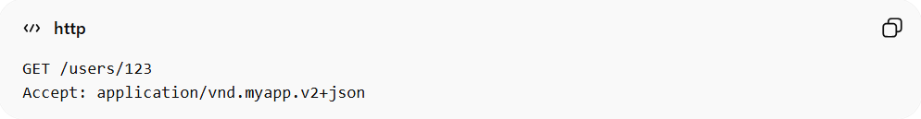
GET /users/123
Accept: application/vnd.myapp.v2+json
Response:
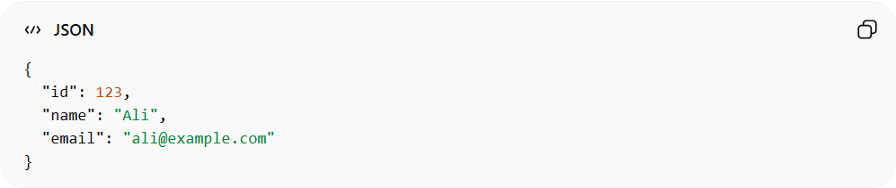
{
"id": 123,
"name": "Ali",
"email": "ali@example.com"
}

🧩 How It Works
# Source: AI Source: Provided by: [Data Path: Persons Table -> ID Column: 1, Name_En Column: Motasem Essam] -> From: [ChatGPT] on [1/19/2026]
- application → standard MIME type
- vnd.myapp → vendor-specific identifier
- v1 / v2 → version
- +json → response format

1️⃣ application → Standard MIME Type
# Source: AI Source: Provided by: [Data Path: Persons Table -> ID Column: 1, Name_En Column: Motasem Essam] -> From: [ChatGPT] on [1/19/2026]
application is the top-level type in the MIME (Multipurpose Internet Mail Extensions) system.
🔑 What it means
- Indicates the general category of the data
- Used by browsers and clients to understand how to handle the response
📦 Common MIME Types
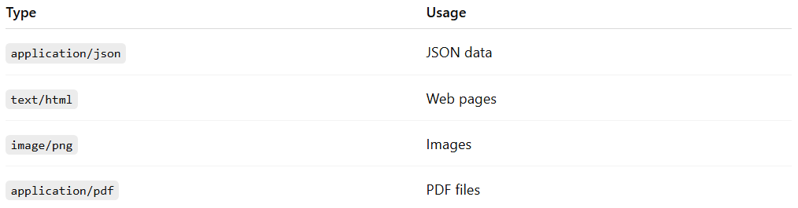
Type | Usage
application/json | JSON data
text/html | Web pages
image/png | Images
application/pdf | PDF files
💡 In APIs
- application is used because APIs usually return structured data (JSON, XML)
- It tells the client:
👉 “This is data, not a webpage or image”

2️⃣ vnd.myapp → Vendor-Specific Identifier
# Source: AI Source: Provided by: [Data Path: Persons Table -> ID Column: 1, Name_En Column: Motasem Essam] -> From: [ChatGPT] on [1/19/2026]
vnd stands for vendor, and myapp is your application or company name.
🔑 What it means
- Identifies who owns or defines this format
- Prevents conflicts with standard media types
📌 Format
vnd.<company-or-app-name>
🧱 Examples
- vnd.github → GitHub API
- vnd.google → Google APIs
- vnd.mycompany.orders → Custom enterprise API
💡 Why it's important
- Makes your API unique and identifiable
- Allows custom formats without breaking standards

3️⃣ v1 / v2 → Version
# Source: AI Source: Provided by: [Data Path: Persons Table -> ID Column: 1, Name_En Column: Motasem Essam] -> From: [ChatGPT] on [1/19/2026]
This part defines the version of the API representation.
🔑 What it means
- Indicates which version of the response format the client wants
- Helps maintain backward compatibility
🧱 Example
- v1 → basic response
- v2 → extended or modified response
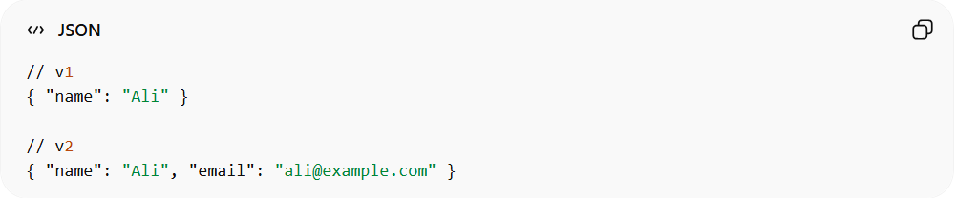
// v1
{ "name": "Ali" }

// v2
{ "name": "Ali", "email": "ali@example.com" }
💡 Why it's important
- Allows API evolution without breaking old clients
- Keeps multiple versions running simultaneously

4️⃣ +json → Response Format
# Source: AI Source: Provided by: [Data Path: Persons Table -> ID Column: 1, Name_En Column: Motasem Essam] -> From: [ChatGPT] on [1/19/2026]
The +json suffix indicates the actual data format of the response.
🔑 What it means
- Tells the client how to parse the data
- Even with custom types, the format is still JSON
🧱 Examples
- +json → JSON format
- +xml → XML format
💡 Why use +json instead of just json
- Combines custom media type + standard format
- Example:
  - application/json → generic JSON
  - application/vnd.myapp.v1+json → custom versioned JSON

🧠 Full Breakdown Together
# Source: AI Source: Provided by: [Data Path: Persons Table -> ID Column: 1, Name_En Column: Motasem Essam] -> From: [ChatGPT] on [1/19/2026]
application/vnd.myapp.v1+json
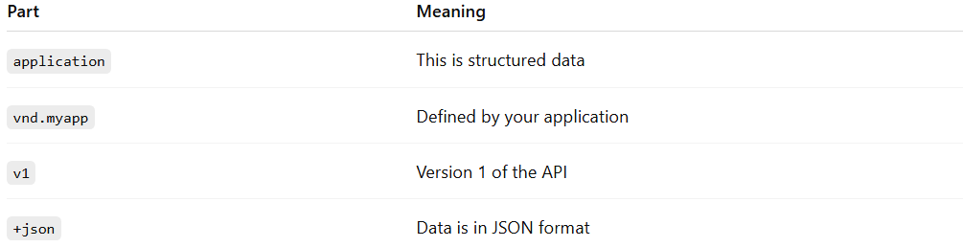
Part | Meaning
application | This is structured data
vnd.myapp | Defined by your application
v1 | Version 1 of the API
+json | Data is in JSON format

💡 Final Idea
# Source: AI Source: Provided by: [Data Path: Persons Table -> ID Column: 1, Name_En Column: Motasem Essam] -> From: [ChatGPT] on [1/19/2026]
This format allows you to version your API without changing URLs, while still keeping responses standard and machine-readable.

✅ Advantages
# Source: AI Source: Provided by: [Data Path: Persons Table -> ID Column: 1, Name_En Column: Motasem Essam] -> From: [ChatGPT] on [1/19/2026]
- Very clean URLs (no version in path)
- Fully aligned with REST principles
- Supports multiple formats and versions together

❌ Disadvantages
# Source: AI Source: Provided by: [Data Path: Persons Table -> ID Column: 1, Name_En Column: Motasem Essam] -> From: [ChatGPT] on [1/19/2026]
- More complex to implement and understand
- Harder to test manually (requires custom headers)
- Less visible than URL versioning

⚠️ Common Mistakes
# Source: AI Source: Provided by: [Data Path: Persons Table -> ID Column: 1, Name_En Column: Motasem Essam] -> From: [ChatGPT] on [1/19/2026]
- Incorrect media type format ❌
- Not documenting header usage clearly ❌
- Mixing with other versioning strategies inconsistently ❌

💡 Summary
# Source: AI Source: Provided by: [Data Path: Persons Table -> ID Column: 1, Name_En Column: Motasem Essam] -> From: [ChatGPT] on [1/19/2026]
Media Type Versioning lets clients request a specific version of a resource representation using HTTP headers instead of changing the endpoint.

